AnswerBot
AI-Powered FAQ & Customer Support Automation

A secure REST API platform for FAQ creation, authentication, and AI-assisted content management
Node.js · Express.js · MongoDB · Mongoose · JWT · bcrypt · Google Gemini
Team leader: K FARHEEN
TEAM ID:SWTID-2026-1607

TEAM LEADER – FARHEEN K :21AAB38FBEB91F5BD3C4E9471018DC25

TEAM MEMBERS
1.Abhinaya V : 06CD6F59D3D2F3A9B6F458BB54807857
2.Subhiksha Shri S : A12AB1423AA59FFB30745B3519418E3B
3.Aditya A : 235FC72072A60D980E248858FBE5E4EA
4.Lavanya M : 578796BC63EFB0BAA104A7AD6D7C0B0F

- Project Overview

AnswerBot (AI FAQ Assistant) is a REST API backend that helps teams create, organize, search, and manage FAQs with the help of AI.
- Backend: Node.js and Express.js
- Database: MongoDB with Mongoose ODM for schema modeling and validation
- Security: JWT (JSON Web Tokens) for stateless sessions and route protection; bcrypt for password hashing
- AI: Google Gemini SDK generates FAQ questions, answers, and categories from a topic
- Reliability: Centralized error handling that returns clean, sanitized responses and never leaks database internals

2. Case Study

Background
Kani is a customer support operations manager. Her team handles a large backlog of repetitive customer questions, and she struggles to organize entries, classify topics, write clear answers, and track what customers ask most.

Problems
- Creating and maintaining up-to-date documentation takes too much effort.
- There is little visibility into search keywords and how quickly queries are resolved.
- Drafting detailed support answers by hand is slow.
- There is no permission layer to protect private documentation from unauthorized edits.

Solution
AnswerBot provides a centralized, secure API that separates business logic from the frontend. It combines authentication, FAQ management, category organization, keyword search, and AI-powered generation in one backend.

Usage
User type | What they can do
Authenticated creator | Register, log in, generate FAQs with AI, create FAQs, update or delete their own FAQs
Public / consumer | Browse published FAQs and search by keyword

Outcome
- Less manual work and faster FAQ creation
- Data integrity enforced through Mongoose schema validation
- Only the original author can modify or delete a FAQ
- Fast, real-time search through indexed data

3. Key Features
Feature | Description
JWT Authentication & Authorization | Token-based protection for private endpoints
AI FAQ Generation | Google Gemini generates questions, answers, and categories from a topic
FAQ Search | Keyword-based search for fast retrieval
Full CRUD | Create, read, update, and delete FAQs
Category Management | FAQs grouped into categories for easy navigation
Password Encryption | Passwords hashed with bcrypt before storage
Centralized Error Handling | Consistent, standardized error responses
Schema Validation | Mongoose validates data before saving
RESTful Design | Modular Express routes, easy to scale
MongoDB Integration | Flexible NoSQL storage through Mongoose

4. Requirements

4.1 Software
Requirement | Purpose
Windows 10/11, macOS, or Linux | Cross-platform support
Node.js v18+ | Runtime for server logic
npm v9+ | Dependency management
Express.js v4/v5 | Routing framework for the REST API
MongoDB + Mongoose | Database and ODM
Postman / ThunderClient | API testing
VS Code (or similar IDE) | Code editor

4.2 Hardware
Component | Requirement
Processor | Intel Core i5 (8th Gen+) / AMD Ryzen 5 or equivalent
RAM | 8 GB minimum (16 GB recommended)
Storage | 1 GB free disk space

5. System Architecture
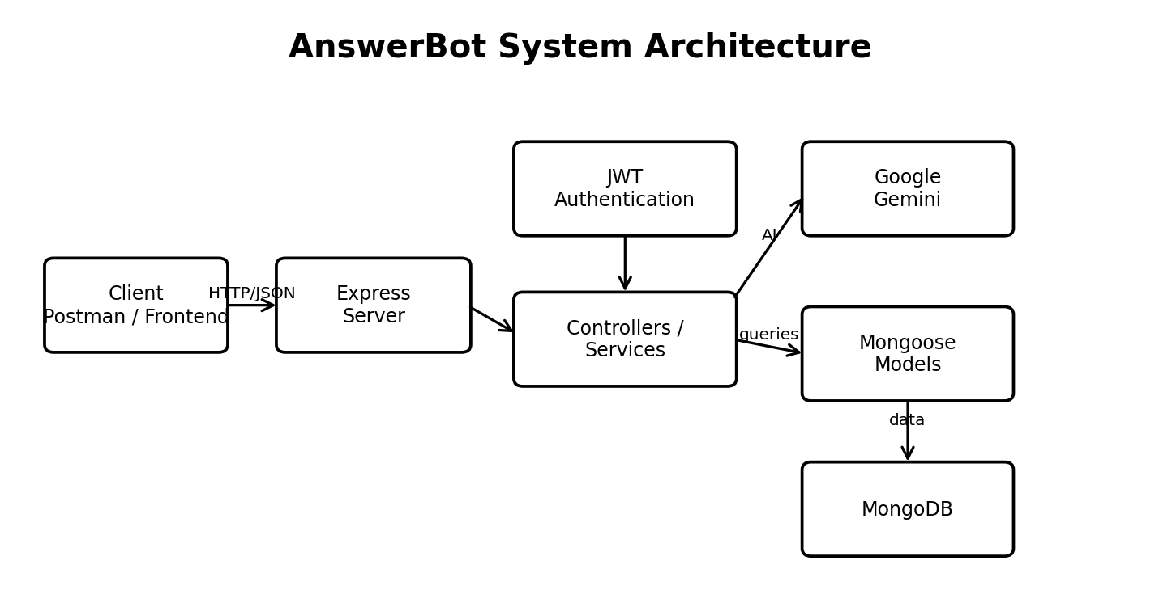
Figure: Layered request flow from client to Express, authentication, services, Mongoose, MongoDB, and Gemini AI.
Every request passes through a layered pipeline before it reaches the data layer.
Client (Postman / Frontend)
|
v
Express Server Gateway - routing, JSON parsing, CORS
|
v
Authentication Middleware - verifies JWT, checks access
|
v
Controllers / Services - business logic
| \--> Google Gemini (AI generation)
v
Mongoose Models - validation and queries
|
v
MongoDB

Components
Component | Responsibility
Interface | Tools such as Postman send requests and receive JSON
Express Server Gateway | Listens on the port, maps HTTP methods (GET, POST, PUT, DELETE), parses JSON, handles CORS
Authentication Middleware | Reads the token from the header, validates it, and checks authorization for protected routes
Controllers / Services | Apply domain rules for users, FAQs, and AI requests
Database Layer | Mongoose converts application logic into MongoDB queries
AI Service | Uses the Google Gemini SDK to generate FAQs and topic suggestions

MVC Pattern
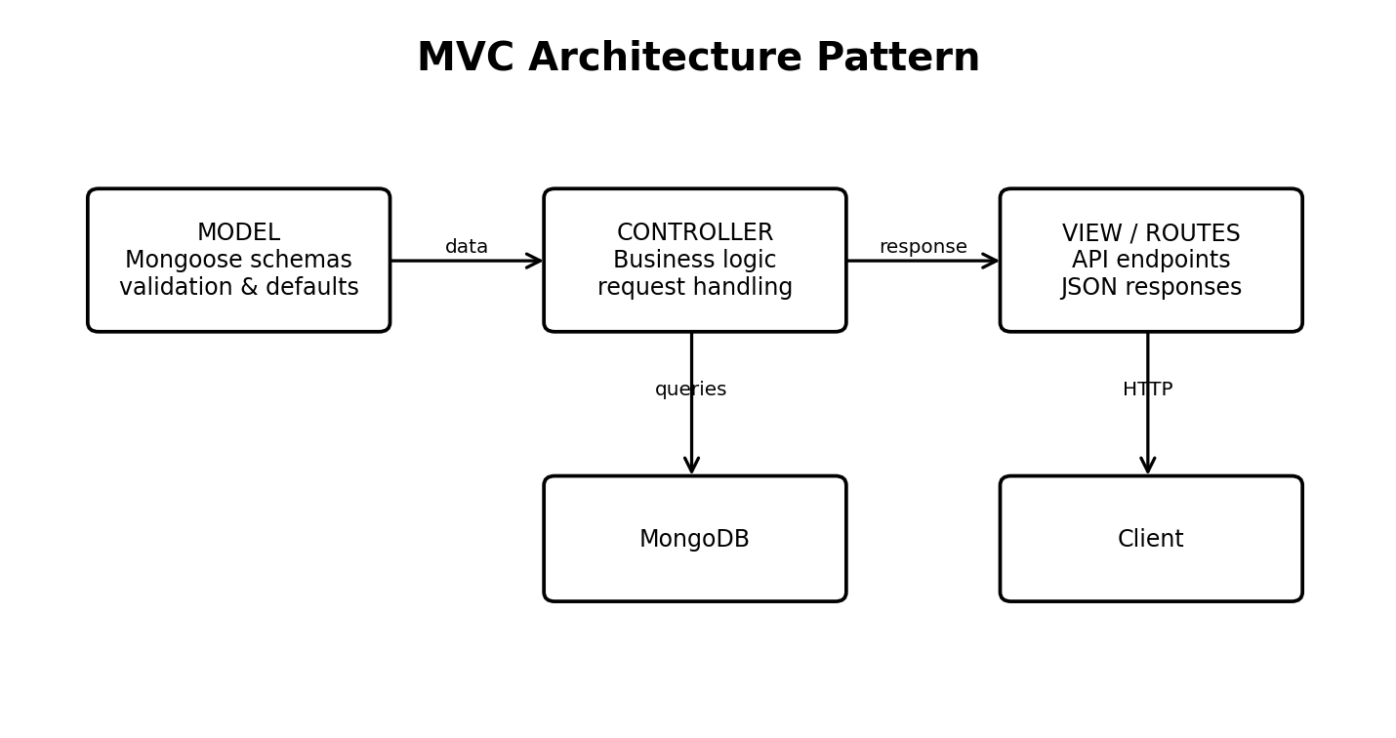
Figure: MVC mapping for the headless REST API architecture.
- Model: Mongoose schemas define fields, rules, and defaults before data is saved.
- Controller: Receives requests, validates input, calls models or services, and returns JSON responses.
- View (API Routing Layer): This is a headless backend, so there are no HTML views. The routes map URL paths to controller handlers.

6. Database Design
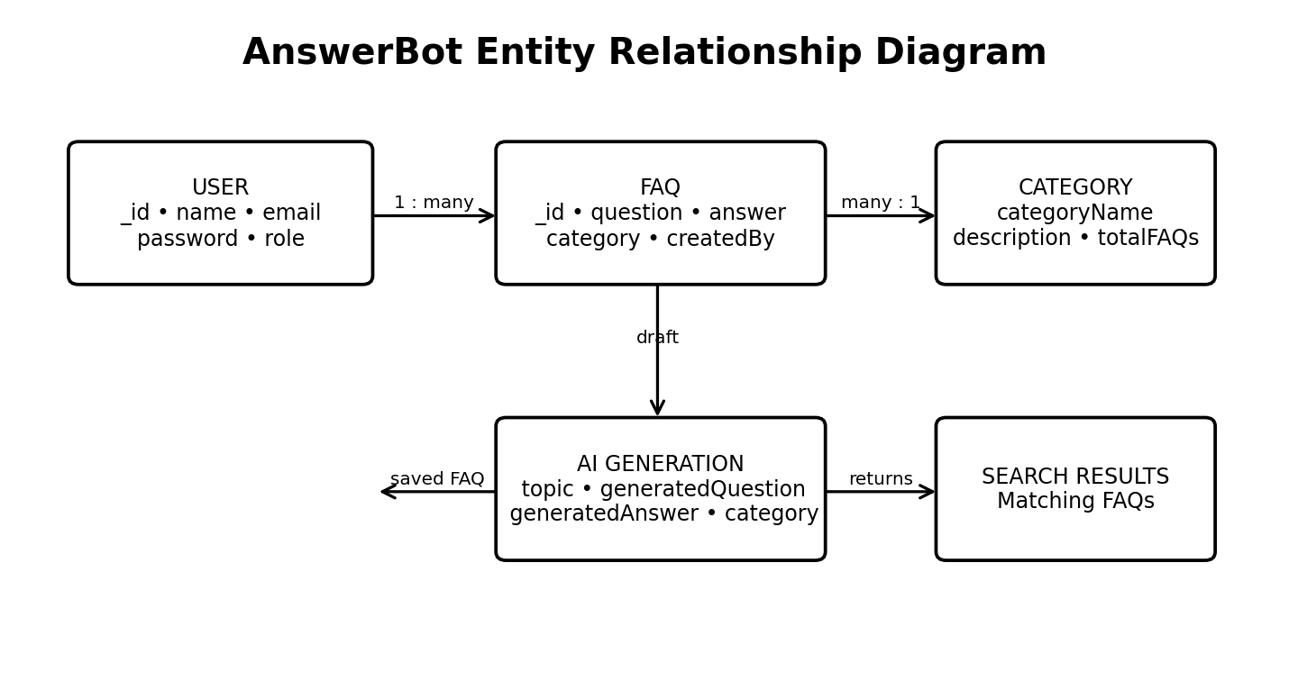
Figure: User, FAQ, Category, AI Generation, and Search Result relationships.

6.1 User (persisted)
Field | Type | Notes
_id | ObjectId | Primary key
name | String | Required
email | String | Required, unique
password | String | Required, stored hashed
role | String | Default: "user"
createdAt, updatedAt | Date | Automatic timestamps

6.2 FAQ (persisted)
Field | Type | Notes
_id | ObjectId | Primary key
question | String | Required
answer | String | Required
category | String | Required
createdBy | ObjectId | Reference to User
createdAt, updatedAt | Date | Automatic timestamps

6.3 AI Generation (logical)
Generated dynamically and not stored until saved as an FAQ: topic, generatedQuestion, generatedAnswer, generatedCategory, generatedAt.

6.4 Category (logical)
categoryName, description, totalFAQs

6.5 Relationships
Relationship | Type | Meaning
User → FAQ | One-to-Many | A user can create many FAQs
Category → FAQ | One-to-Many | A category contains many FAQs
User → AI-generated FAQ | One-to-Many | A user can generate many AI drafts, which can be saved as FAQs
FAQ → Search Results | Logical | Search queries return matching FAQs

7. Roles and Permissions
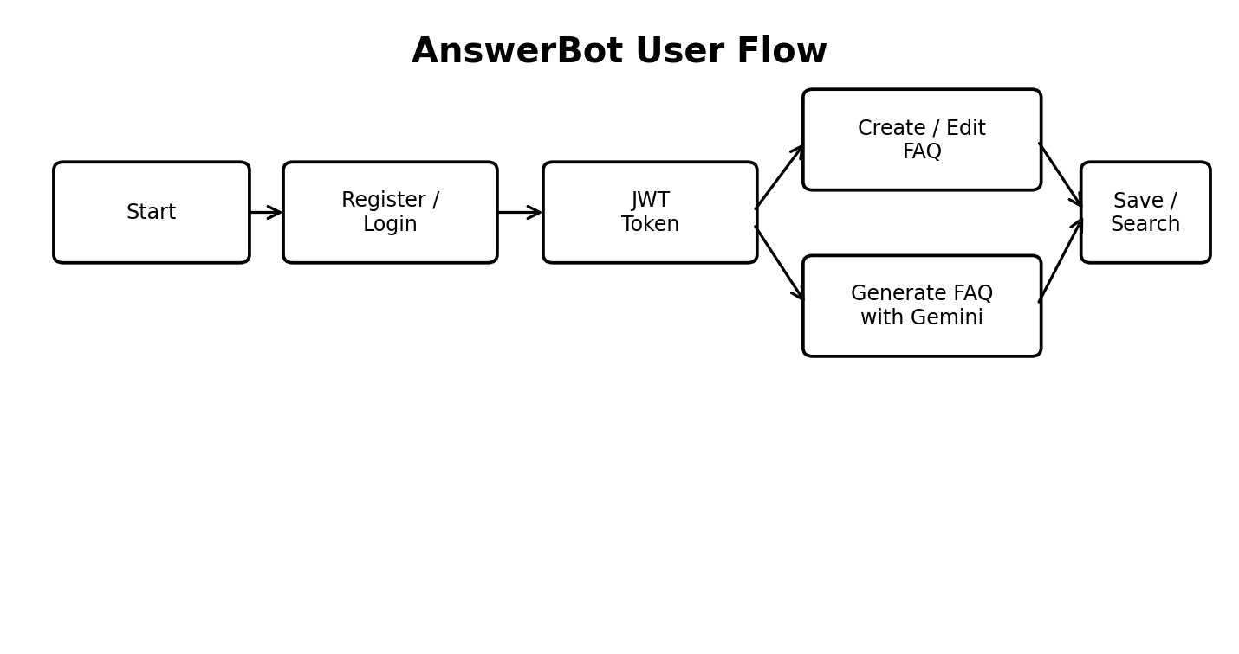
Figure: Typical authenticated user flow through AnswerBot.
Capability | Public | Auth. User | Creator | Admin
View published FAQs | ✔ | ✔ | ✔ | ✔
Search FAQs | ✔ | ✔ | ✔ | ✔
View own profile | ✘ | ✔ | ✔ | ✔
Generate AI-assisted answers | ✘ | ✔ | ✔ | ✔
Create FAQs | ✘ | ✘ | ✔ | ✔
Edit / delete own FAQs | ✘ | ✘ | ✔ | ✔
Organize FAQs by category | ✘ | ✘ | ✔ | ✔
Edit / delete any FAQ | ✘ | ✘ | ✘ | ✔
Manage users and categories | ✘ | ✘ | ✘ | ✔
Monitor AI-generated content | ✘ | ✘ | ✘ | ✔

8. Project Setup

8.1 Create the project
mkdir answerbot
cd answerbot
mkdir src
code .

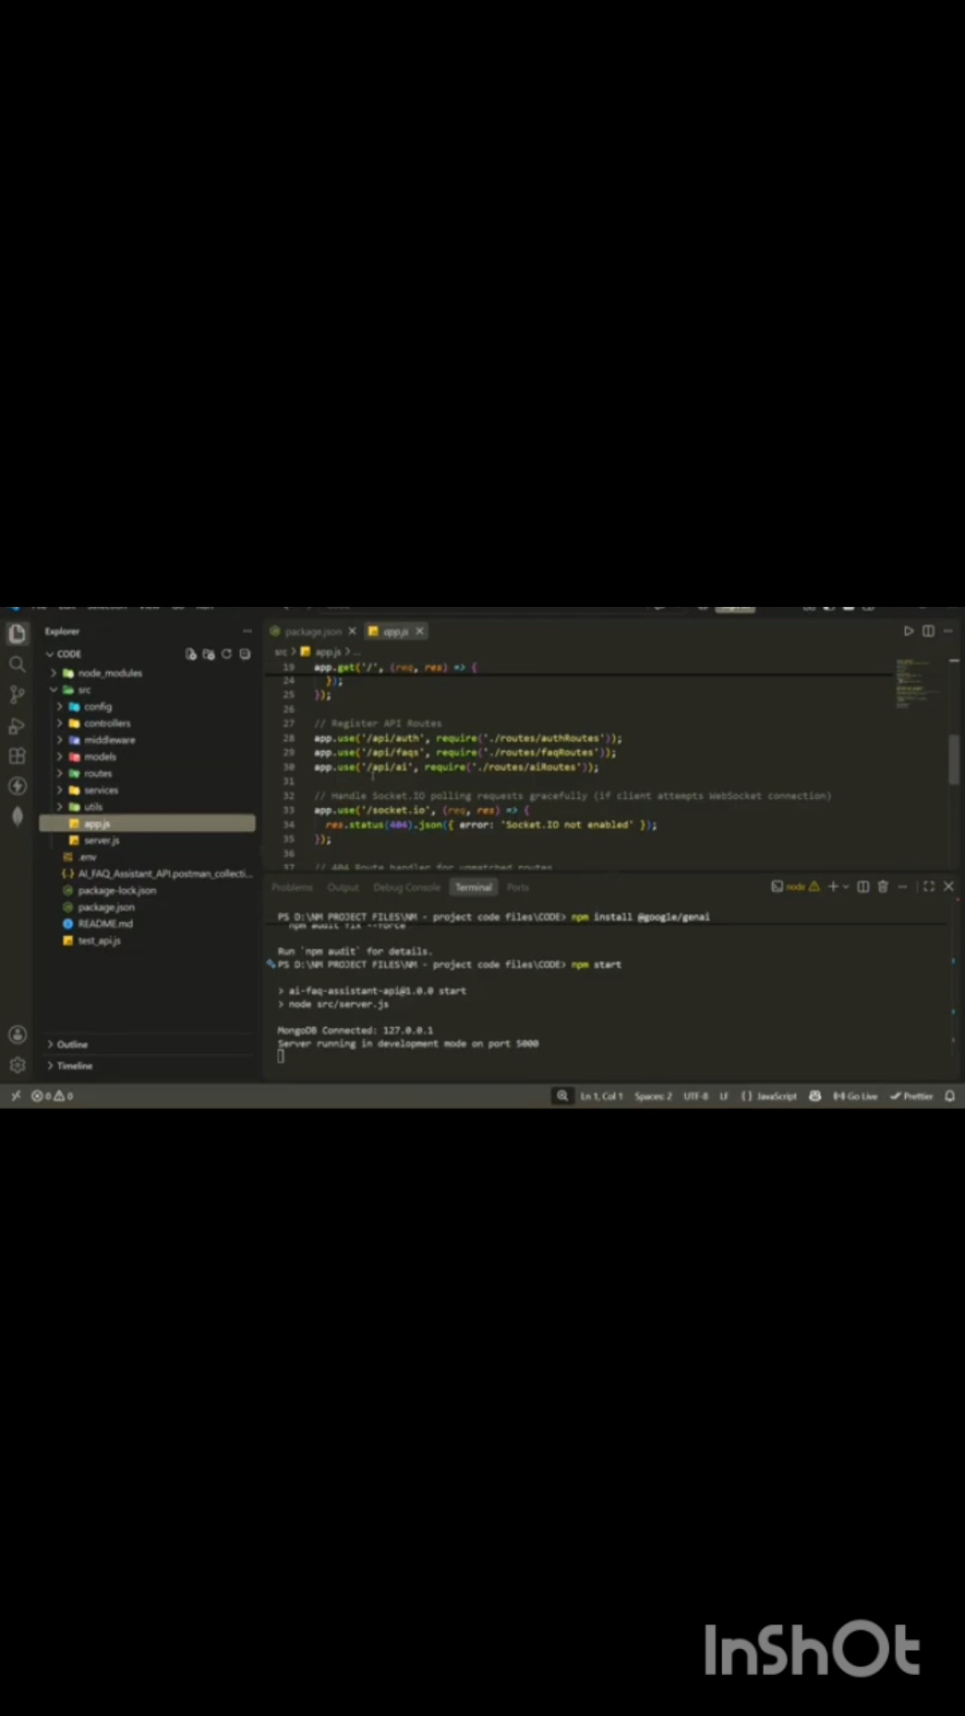
8.2 Install dependencies
npm init -y
npm install express mongoose dotenv cors jsonwebtoken bcrypt @google/genai

8.3 Folder structure
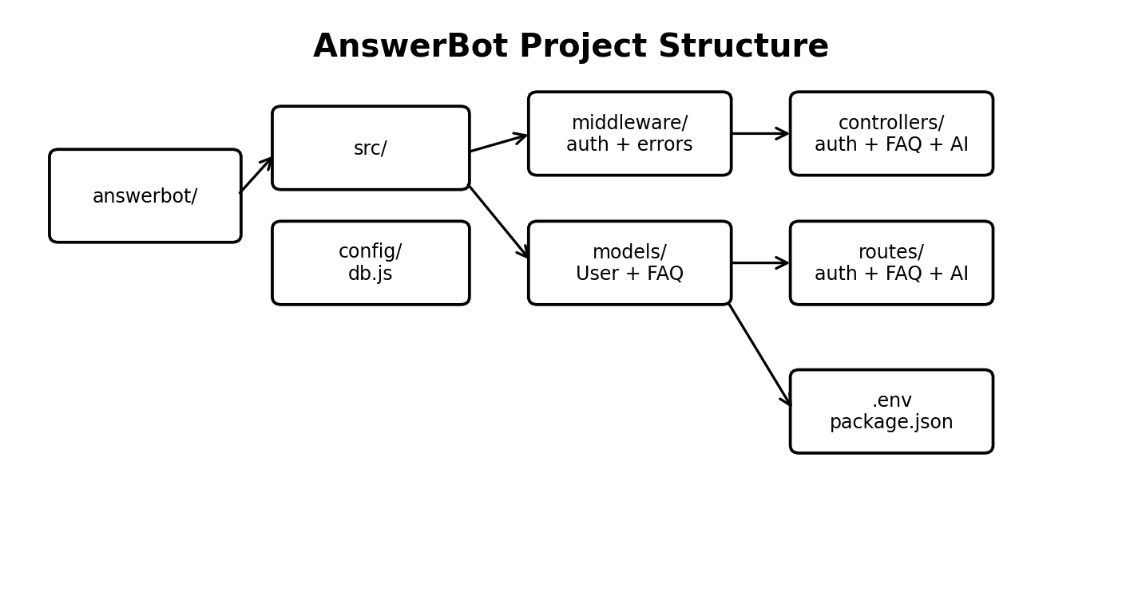
Figure: Visual project folder structure.
answerbot/
|-- src/
| |-- server.js # Entry point: env, DB connect, start server
| |-- app.js # Express app setup and route mounting
| |-- config/
| | `-- db.js # MongoDB connection
| |-- middleware/
| | |-- authMiddleware.js # JWT verification
| | `-- errorMiddleware.js # Centralized error handler
| |-- models/
| | |-- User.js
| | `-- FAQ.js
| |-- controllers/
| | |-- authController.js
| | |-- faqController.js
| | `-- aiController.js
| `-- routes/
| |-- authRoutes.js
| |-- faqRoutes.js
| `-- aiRoutes.js
|-- .env
|-- .gitignore
`-- package.json

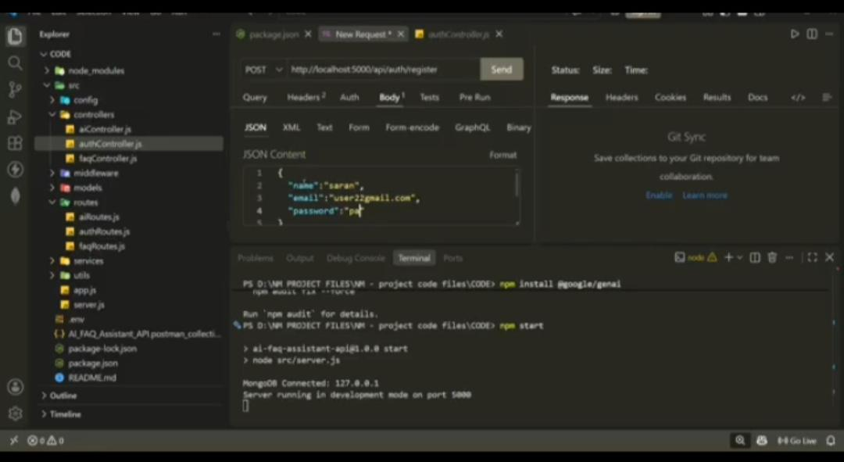
8.4 Environment variables (.env)

PORT=5000
MONGO_URI=mongodb://localhost:27017/answerbot
JWT_SECRET=your_strong_secret_here
JWT_EXPIRES_IN=7d
GEMINI_API_KEY=your_gemini_api_key

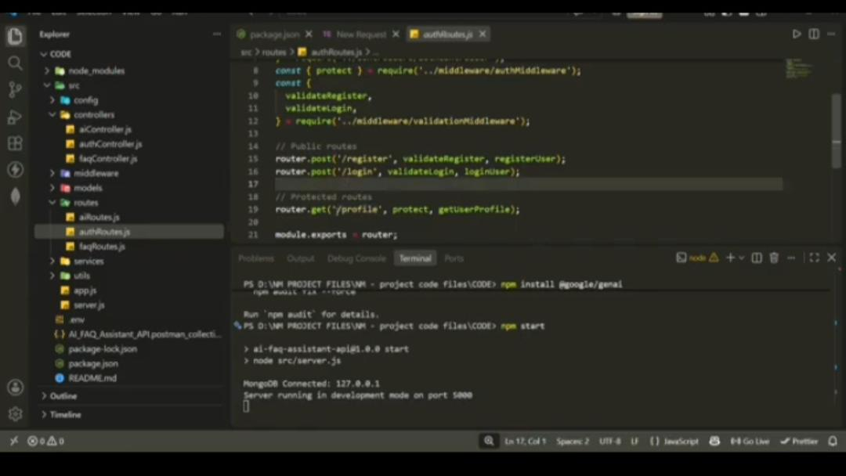
8.5 Run the application

npm run dev

9. Backend Implementation
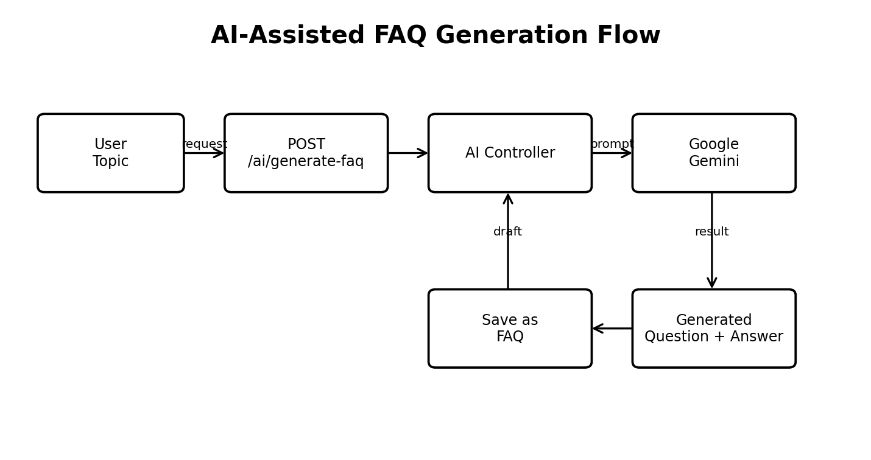
Figure: AI-assisted FAQ generation flow using the Gemini service.
File | Purpose
src/server.js | Loads environment variables, connects to MongoDB, and starts the server on the configured port
src/app.js | Creates the Express app, applies CORS and JSON parsing, mounts routes, and registers the error handler
src/middleware/authMiddleware.js | Extracts the Bearer token from the Authorization header, verifies it, and attaches the user to the request
src/middleware/errorMiddleware.js | Catches errors and returns consistent, sanitized JSON responses
src/models/User.js | User schema with validation and a pre-save hook that hashes passwords with bcrypt
src/models/FAQ.js | FAQ schema with a createdBy reference to the User
src/routes/authRoutes.js | Public registration and login
src/routes/faqRoutes.js | FAQ CRUD and search
src/routes/aiRoutes.js | AI-powered FAQ generation
Paste your final source code for each file into the matching section or repository when submitting.

10. API Reference
Base URL: http://localhost:5000/api
Method | Endpoint | Access | Description
POST | /auth/register | Public | Register a new user
POST | /auth/login | Public | Log in and receive a JWT
GET | /faqs | Public | List all FAQs
GET | /faqs/search?q=keyword | Public | Search FAQs by keyword
POST | /faqs | Private | Create a FAQ
PUT | /faqs/:id | Private (owner) | Update a FAQ
DELETE | /faqs/:id | Private (owner) | Delete a FAQ
POST | /ai/generate-faq | Private | Generate a FAQ from a topic using Gemini

Authentication header for private routes:
Authorization: Bearer <JWT_TOKEN>

Standard error format:
{
"success": false,
"message": "Descriptive error message"
}

11. Testing Guide
Test each endpoint in Postman or ThunderClient in the order below.

11.1 Register a user
POST /api/auth/register (Public)
{
"name": "Priya Sharma",
"email": "priya@writeflow.com",
"password": "securepassword123"
}

11.2 Log in
POST /api/auth/login (Public). Copy the token from the response for the next steps.
{
"email": "priya@writeflow.com",
"password": "securepassword123"
}

11.3 Create a FAQ
POST /api/faqs (Private, Bearer token)
{
"question": "How do I configure custom category tags?",
"answer": "Navigate to the settings panel, add keyword tags, and save the schema.",
"category": "Configuration"
}

11.4 Search FAQs
GET /api/faqs/search?q=configure (Public)

11.5 Generate a FAQ with AI
POST /api/ai/generate-faq (Private, Bearer token)
{
"topic": "Mongoose schema indexing and validation workflow optimization"
}

Expected results
Test | Expected status
Register with new email | 201 Created
Register with existing email | 400 Bad Request
Login with correct credentials | 200 OK with token
Login with wrong password | 401 Unauthorized
Create FAQ without token | 401 Unauthorized
Create FAQ with token | 201 Created
Edit another user's FAQ | 403 Forbidden
Search with matching keyword | 200 OK with results

12. Demo and Resources
- DEMO VIDEO LINK
- https://drive.google.com/file/d/1Er0pE2mlqEftmzD01cUud4VRawx7tYVM/view?usp=drivesdk

